

**CIS 11042 – Practical for Essential of ICT and PC Applications**

Information and communication Technology

Faculty of Technology

South Eastern University of Sri Lanka

Registration Number: SEU/IS/22/ICT/075

Academic year: 22/23

Date: 22.02.2025

**Exercise 01**

1. Open Microsoft Word -> Click **“File”** -> Select **“New”**  -> Click on **“Blank document**

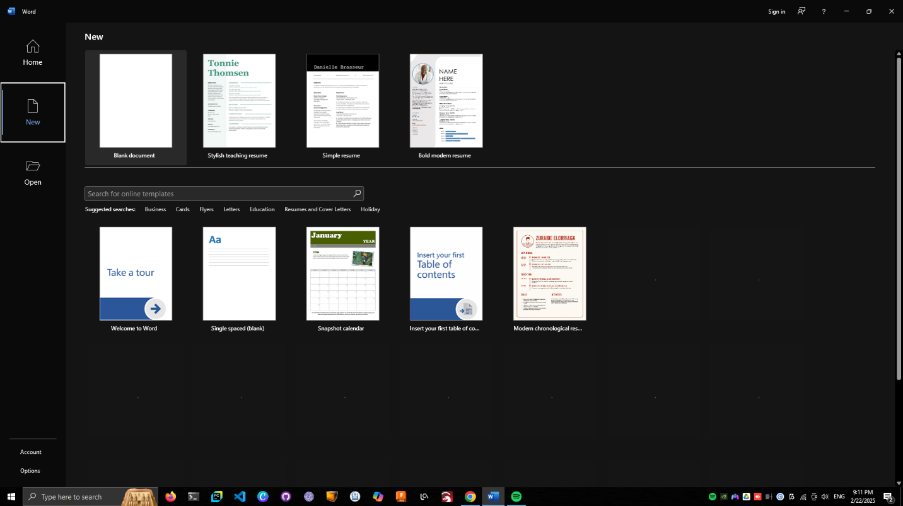

1. Click on **“Customize quick access toolbar”** -> **“More Commands”** -> In the list select N**ew, Spelling & Grammar , Quick Print** -> click on **“Add”** -> click on **“ok”**

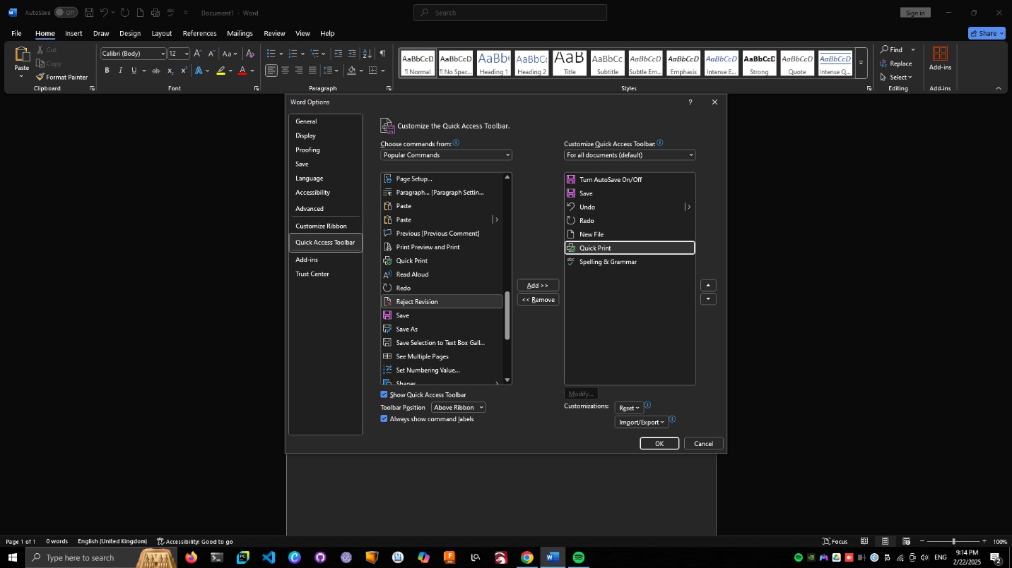

1. Click on any Ribbon menu -> Right click to -> click on Click on **“Collapse the Ribbon”** to hide and switch.

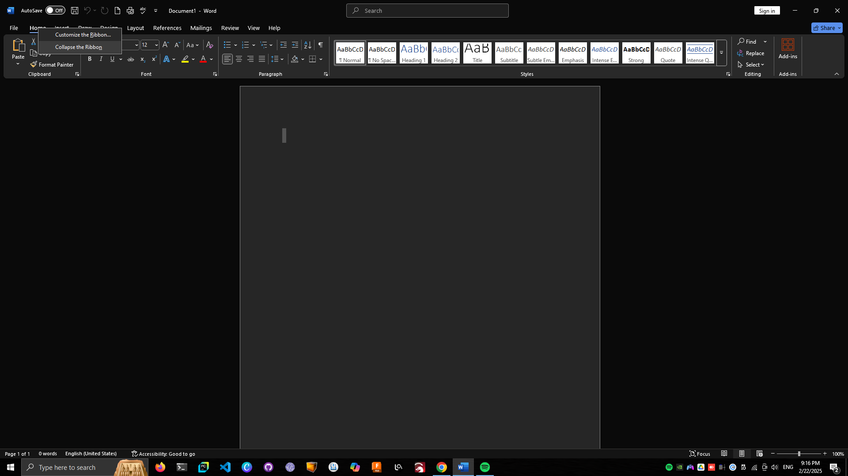

1. Click on **“View”** -> select **“Ruler, Gridline and Navigation Pane”**

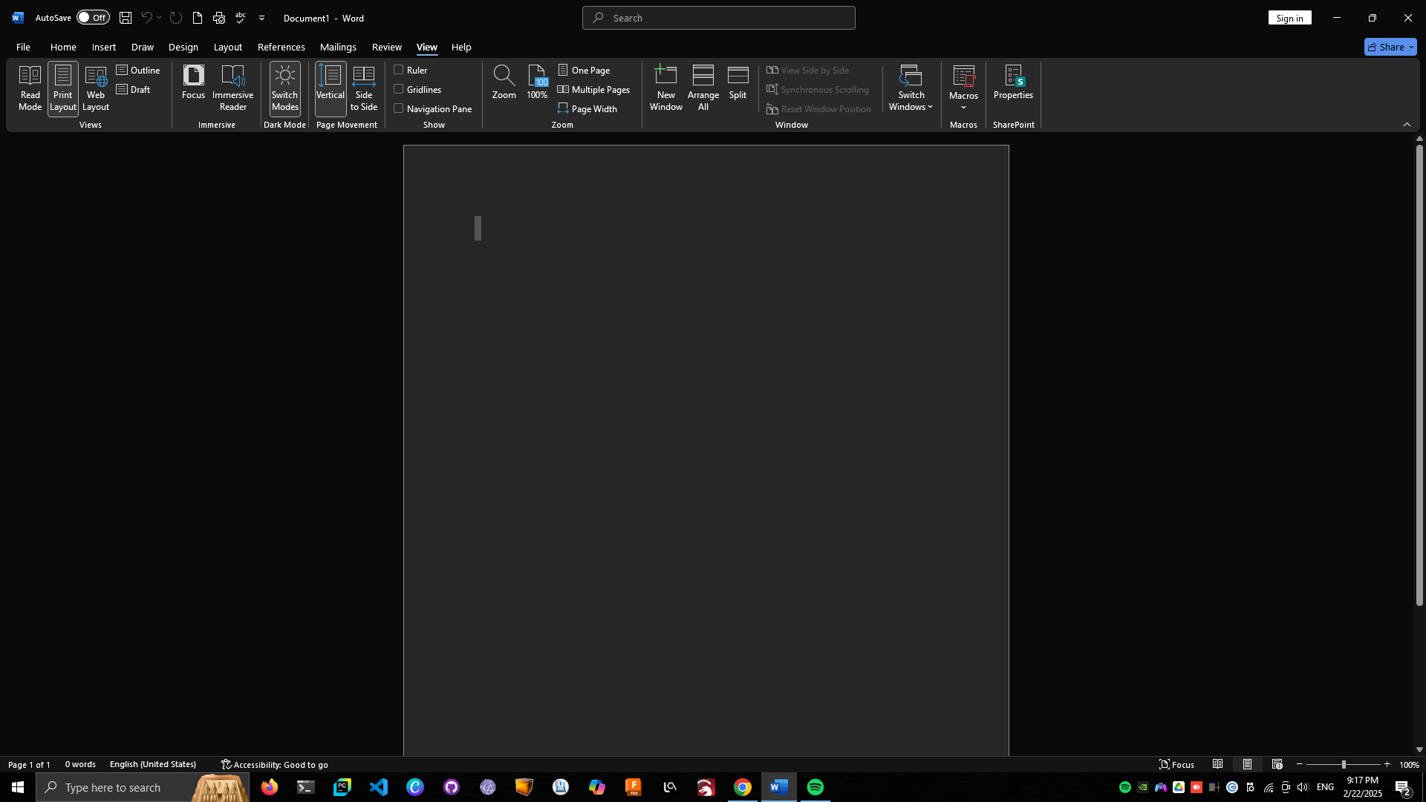

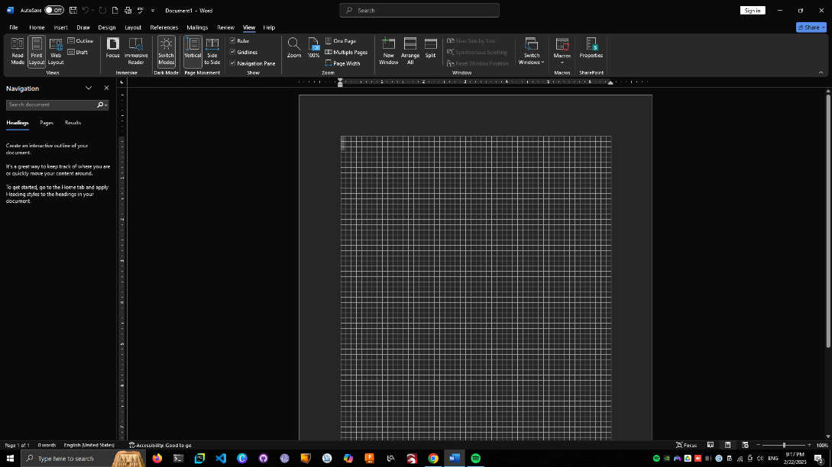

1. Change Zoom of the document by clicking on the **“+”** or **“-“**  button on the lower right corner.

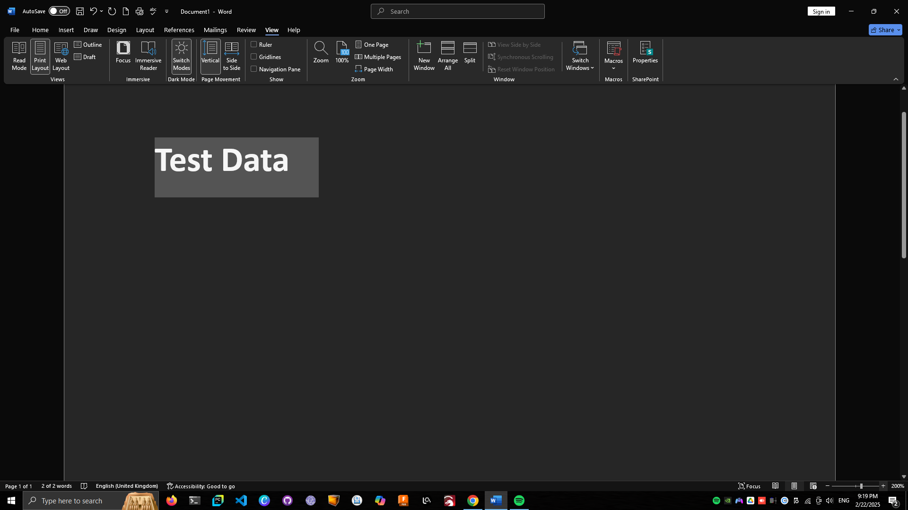

1. Fasdfasdf

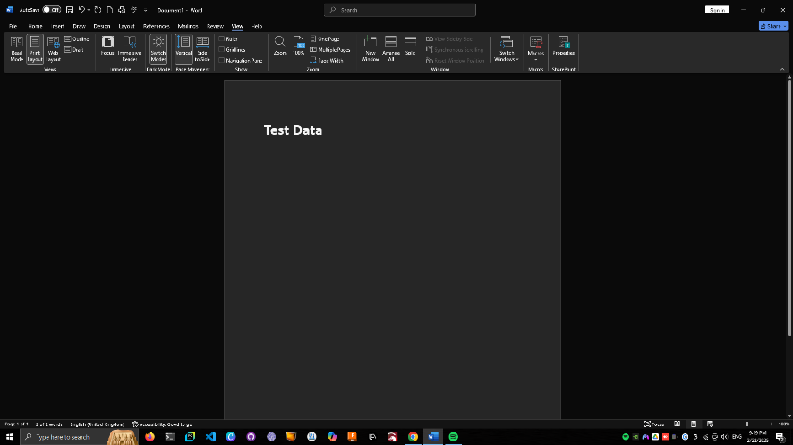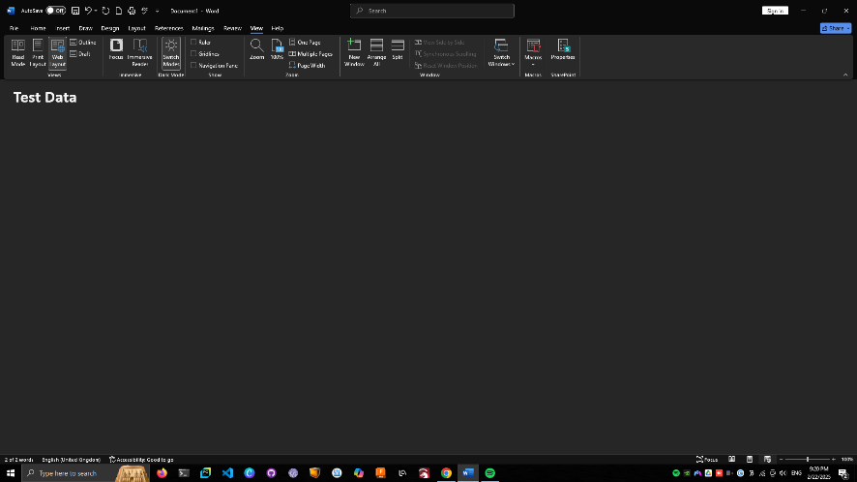

**Print Layout**

**Web Layout**

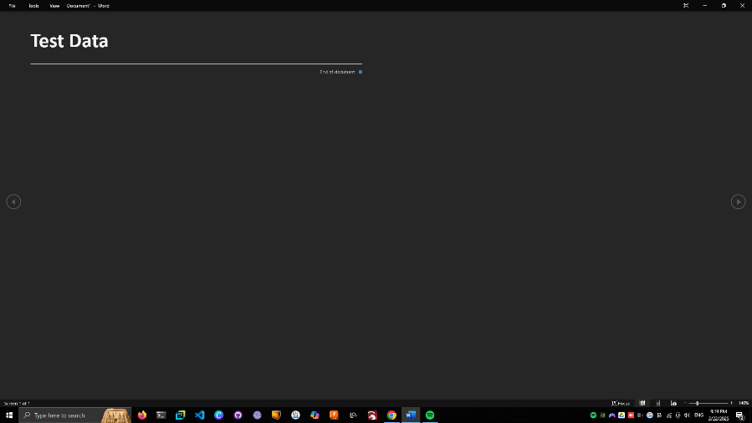

**Read Layout**

1. Click on **“file”** -> right click on file name and pin then unpin

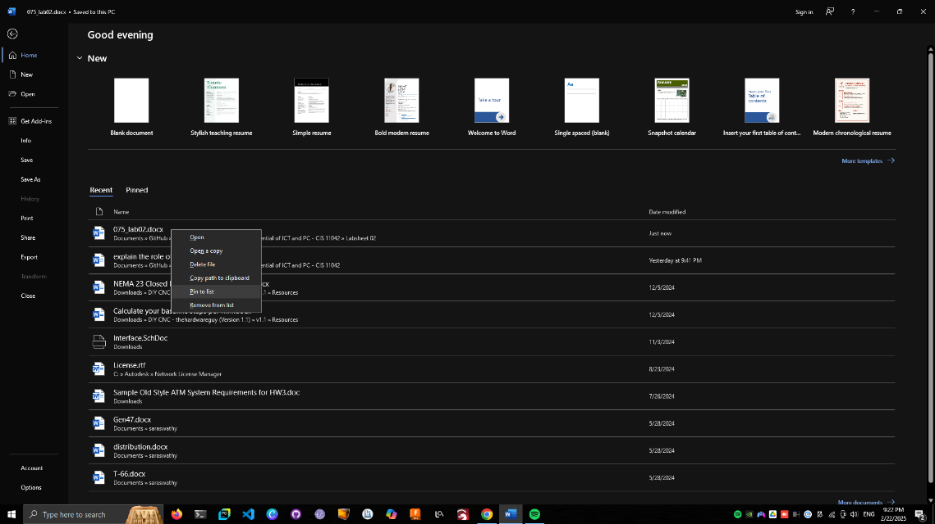

**Exercise 02**

1. Open Microsoft word -> click on **“New”** -> select any template

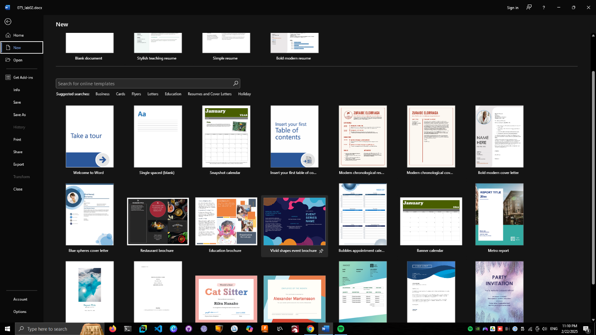

1. Type about Hobby of your choice.
2. Click on **“file”** -> **“Save as”** -> name the doc file as “My hobby”.
3. Click on **“file”** -> go **“option”** -> go **“save”** -> default local file location browse location -> click **“ok”**
4. Click on **“file”** -> **“Export”** -> click on **“Create PDF/XPS”**

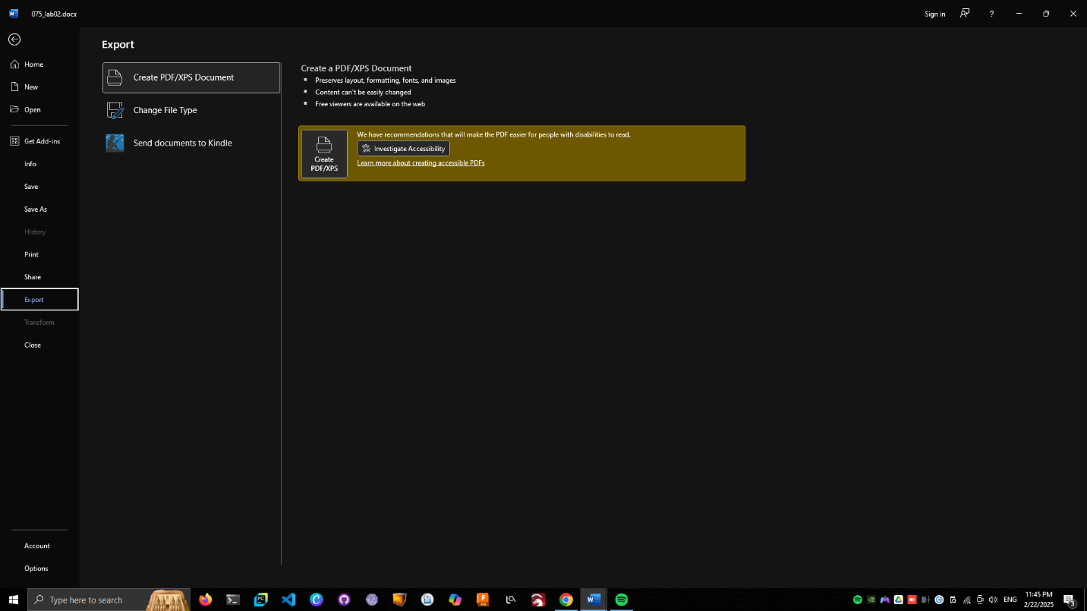

**Exercise 03**

1. Open MS word and type text.
2. 